Graduation project layout

Done by : Mechel Moheb and Pierre Nagy online H24

*Proteus simulation for smart home design.*

*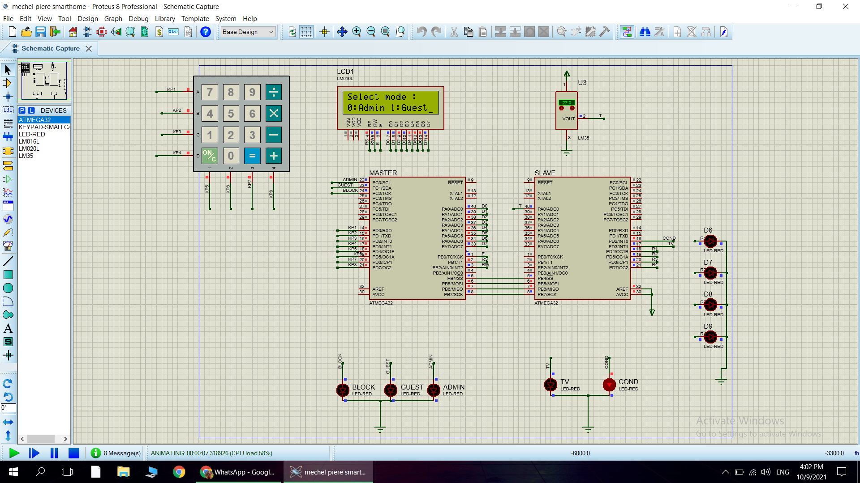*

How the system works :

* When you apply the power on the kit he will ask you to enter what is your user types
* If you applied guest mood, he will make you to enter your guest password after you finish it will make you control the light of 4 rooms
* If you choose admin mood, he will ask to enter your password and set it after it he will make you control 4 rooms and the air conditioner, tv and the to know the temperature inside each room so you can turn on or off the AC
* After it if you turn off the power and return it he will ask for admin or guest password to make you go to menu
* if you entered guest or admin password wrong he will block your user and will not e able to control any thing
* we used master and slave micro controller with spi communication protocol to communicate with each others
* we used key pad so you can enter your passwords and control the rooms from it
* the lcd display will tell you all the information you needed so you can open or close the AC or witch room is on or off and the temperature inside the room